Welcome to the Alberta Group Programs!
These programs were developed at the Red Deer Primary Care Network. All of our participating PCNs/organizations have the opportunity to participate in their continued evolution. They have been shared with about 40 organizations. The goal is for all Albertans to have access to empower them in their daily lives.

About the Programs:

Content and design
- All programs are evidence based
- Concepts are distilled to simple clear messaging
- Designed using the AMSO model developed by Dr. O’Donnell: 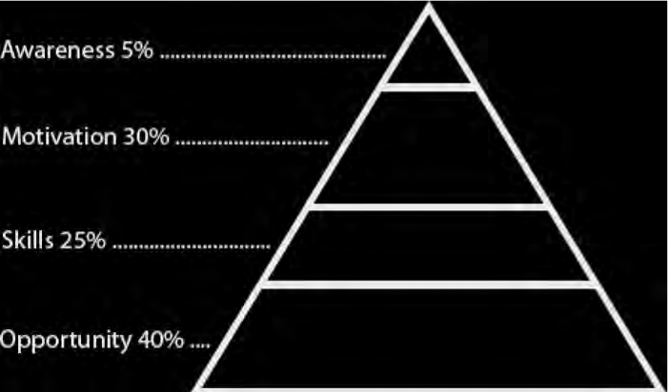
AMSO Framework
Recognizes that lifestyle change can be facilitated through a combination of learning experiences that enhance awareness, increase motivation, and build skills and, most importantly, through the creation of opportunities that open access to environments that make positive health practices the easiest choice.
- Communities of Practice (COPs)quarterly teleconference meetings
  - COPs provide an opportunity to share and plan together. One COP is for facilitators and one for organizational managers.
- Continuous Quality Improvement
  - Programs are reviewed for changes every two years based on, new research, evaluation results and feedback from all coaches.

Target Audience:
- All programs are designed for individuals 18 years and older.

Sharing the Programs

Training and Mentoring
- Quality processes are set to ensure we are delivering a consistent product across the province.
- Coaches must be Health Care Professionals. Use of programs is limited to non-profits.

Presentations
- Organizations are encouraged to present on the group programs at conferences and in the community. Collaborative presentations are encouraged at events such as Provincial PC Conferences and meetings.

Evaluation
- Each organization contributes to the AB annual report by sharing statistics of numbers attending courses and course evaluation. Annual reports are shared with all partners.
- Evaluation tools suggested for the programs are found on the training site. Along with excel documents to make reporting easier. Access can be granted to administration, or evaluators by of an organization by contacting programsharing@rdpcn.com.

Training Options
Virtual training:
At least one person from your organization needs to attend virtual training, and all other staff can then train online. The person who attended virtual training will be the “mentor” in your organization to ensure other staff are ready to deliver the program the way it is intended.

Expectations:
- Allow at least 2 weeks for registration to be processed to give you access to the training site.
- Review participant/ coach manuals and PowerPoints in concurrence with the training videos prior to attending the course (approximately 14 hours).
- You will have an opportunity to be both a facilitator and a participant during the 2 days of training and will receive helpful feedback on your facilitation in a positive environment.
- A Certificate of Coach Training sent to you after completing training.

Online training:
This is best for those who have facilitation training or experience teaching groups:
- FREE- On-line training takes at least 14 hours
- Allow at least 2 weeks to connect to the training site.

Expectations:
- Review all on-line videos in concurrence with participant/ coach manuals and PowerPoints on the website and all additional resources.
- Use the Completion of Coach Training document to guide your training.
- E-mail a completed copy of Completion of Coach Training document within one month of completion to programsharing@rdpcn.com in order to receive your Coach Training Certificate.

Ongoing Support for All Coaches
- Coach Mentorship teleconferences are quarterly. The teleconferences keep coaches up to date with changes to the programs and allow an opportunity to have their questions answered and their suggestions shared. Coaches are encouraged to participate regularly to share issues or successes or to refresh themselves to the program content.

Manual Printing/Ordering
- Organizations can print manuals any time using the PDF format on the AB Program Training website. For professionally bound manuals place orders directly through Suzanne Erickson: CBN commercial solutions 403-214-5917.

All other Inquires:
programsharing@rdpcn.com

