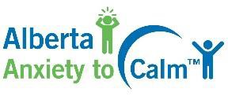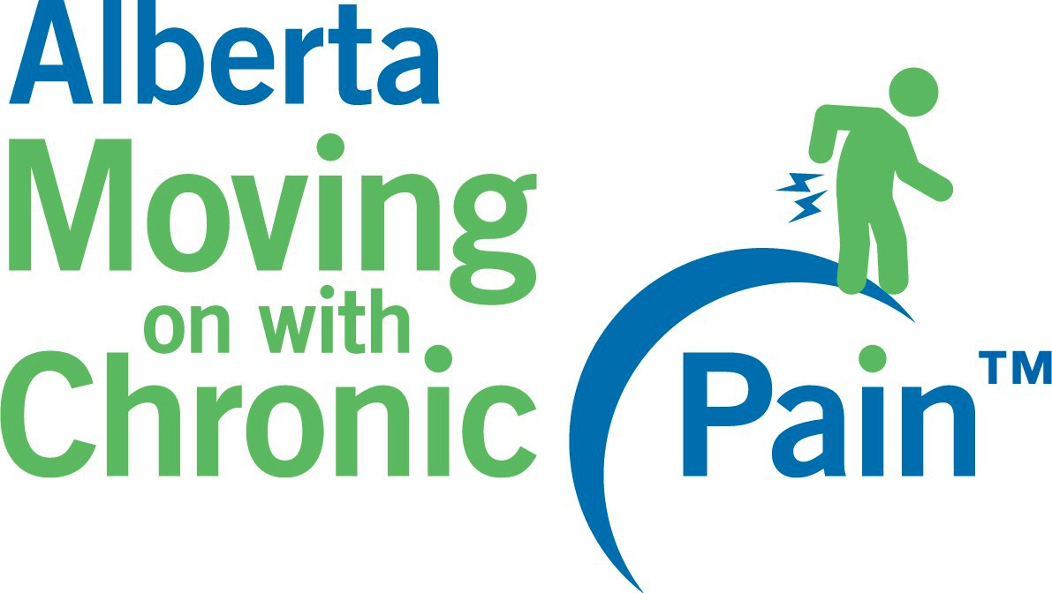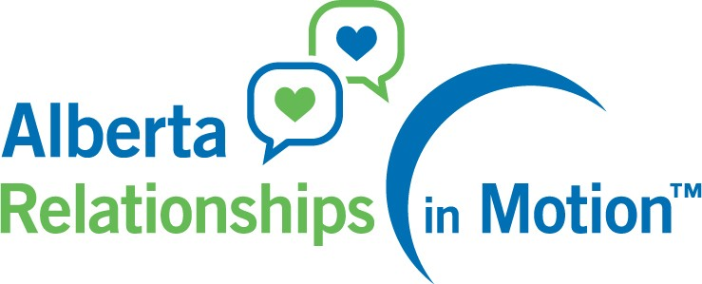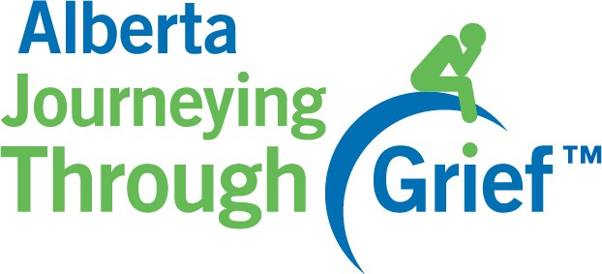
Registration form for Program Training*
*This form can be used for all Alberta Programs (Happiness, Health Basics, Anxiety to Calm, Chronic Pain, Relationships in Motion and Journeying through Grief) for the 2-day virtual training sessions.

Name of Organization: | Location: | Not for Profit: | Yes | No

Name of Manager who will administer the program
Phone #: | Email Address:

Manager is willing to participate in quarterly Alberta Happiness Basics, Alberta Health Basics, and  Alberta Anxiety to Calm Program Sharing Community of Practice meetings. | Yes | No

Name of Evaluator for the program
Phone #: | Email Address:

Organization is willing to complete course evaluations and share evaluation data. | Yes | No
Provide the following information for all interested trainees:
Program Registering for | Purchase Manual and Journal  (Yes/ No) | Name | Designations | E-mail address | Phone # | Facilitation Training Completed (Yes/No) | CBT Training  (Anxiety to Calm Only)  (Yes/ No)
Email completed forms to programsharing@rdpcn.com

